**Exp 4,5 - Practicing DDL Commands (Data Definition Language)**

**• Create table command**

**• Alter table command**

**• Truncate table command**

**• Drop table command**

**create table employees(emp_id numeric(11) primary key, DOB date, f_name varchar(20), l_name varchar(20), hire_date date);**

**desc employees;**

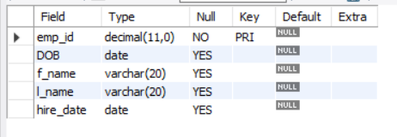

**drop table employees;**



**create table employees(emp_id numeric(11) primary key, DOB date, f_name varchar(20), l_name varchar(20),gender varchar(1), hire_date date);**

**alter table employees add email varchar(20);**

**truncate employees;**

